Use the gutten2 CSV dataset provided for this lab to carry out the following exercise. [There are a total of 107 unique trees in the dataset]. We will be using the Hossfeld IV model for the analysis. The base Hossfeld IV model is specified as follows, where dbh is dbh.cm and A is age.base,



1. Treat the site index (si) predictor as a continuous variable. Create another predictor called Basal Area at Large for each tree (BAL). Expand the base Hossfeld IV model as a NLS model,



(1a) Show the parameter estimates

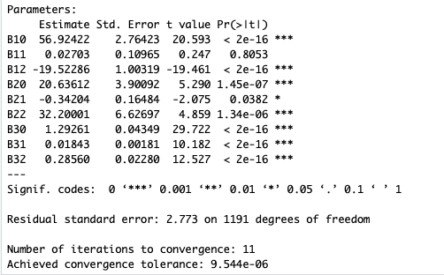

(1b) Show the residual plot

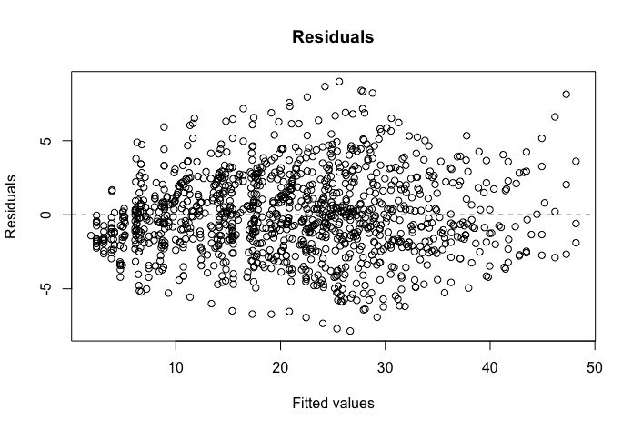

1. Fit a nonlinear mixed effects (NLME)model to the above expanded Hossfeld IV model as follows,



(2a) Show the parameter estimates and interpret the results

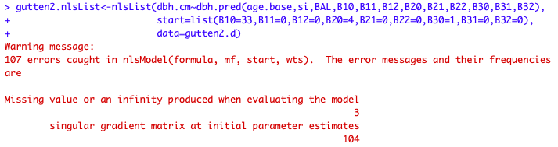

In my opinion, I think there is something wrong in the BAL, so I remove the BAL column and do it again with only six parameters and si. However, something still went wrong with the nlme model. So I maintain that something has changed by the groupedData function.

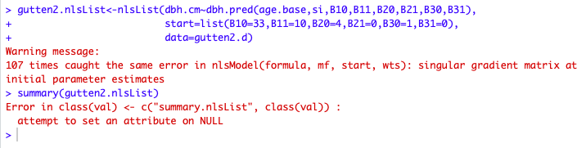

I think I should know more about nlme matrix concept then I can solve this problem.

(2b) Show the residual plot

1. From the exercise (2), expand the fitted NLME model account for the within-tree autocorrelation with ARMA model. Find a suitable ARMA model

(3a) Show the parameter estimates and interpret the results

(3b) Show the autocorrelation plot

(3c) Show the residual plot

(3d) Carry out a likelihood ratio test between the fitted model in (2) and in (3)